Task 01 : Code

import random  
  
from OpenGL.GL import *  
from OpenGL.GLUT import *  
from OpenGL.GLU import *  
  
  
def draw_points(x, y):  
 glPointSize(5) #pixel size. by default 1 thake  
 glBegin(GL_POINTS)  
 glVertex2f(x,y) #jekhane show korbe pixel  
 glEnd()  
  
  
def iterate():  
 glViewport(0, 0, 500, 500)  
 glMatrixMode(GL_PROJECTION)  
 glLoadIdentity()  
 glOrtho(0.0, 500, 0.0, 500, 0.0, 1.0)  
 glMatrixMode (GL_MODELVIEW)  
 glLoadIdentity()  
  
a = random.sample(range(100, 400), 50)  
b = random.sample(range(100, 400), 50)  
  
def showScreen():  
 glClear(GL_COLOR_BUFFER_BIT | GL_DEPTH_BUFFER_BIT)  
 glLoadIdentity()  
 iterate()  
 glColor3f(1.0, 1.0, 0.0) #konokichur color set (RGB)  
 #call the draw methods here  
  
  
 for i in range(50):  
 draw_points(a[i], b[i])  
  
 glutSwapBuffers()  
  
  
  
glutInit()  
glutInitDisplayMode(GLUT_RGBA)  
glutInitWindowSize(500, 500) #window size  
glutInitWindowPosition(0, 0)  
wind = glutCreateWindow(b"OpenGL Coding Practice") #window name  
glutDisplayFunc(showScreen)  
  
glutMainLoop()

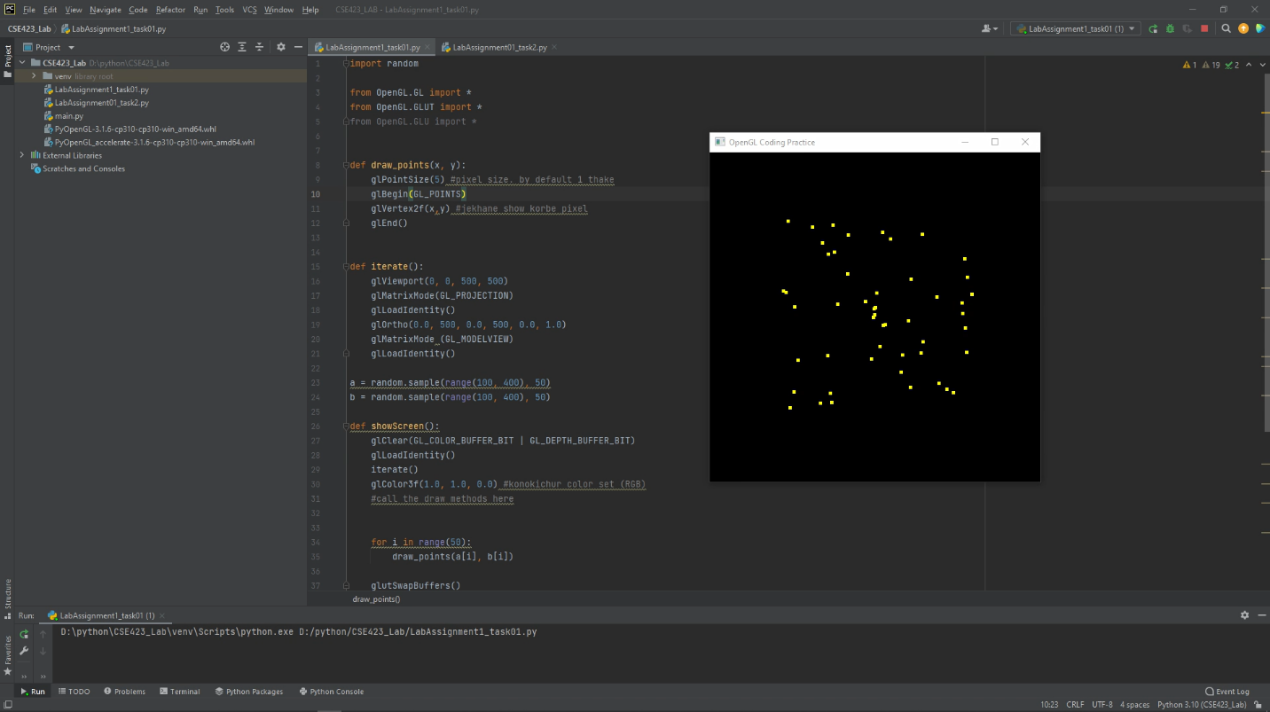

Task 02 :

from OpenGL.GL import *  
from OpenGL.GLUT import *  
from OpenGL.GLU import *  
  
  
def draw_points(x, y):  
 glPointSize(10) #pixel size. by default 1 thake  
 glBegin(GL_POINTS)   
 glVertex2f(x,y) #jekhane show korbe pixel  
 glEnd()  
  
def draw_lines(x1, y1, x2, y2, r, g, b):  
 glLineWidth(5)  
 glBegin(GL_LINES)  
 glColor3f(r/255, g/255, b/255)  
 glVertex2f(x1, y1) #jekhane show korbe pixel  
 glVertex2f(x2, y2) #jekhane show korbe pixel  
 glEnd()  
  
  
  
def iterate():  
 glViewport(0, 0, 500, 500)  
 glMatrixMode(GL_PROJECTION)  
 glLoadIdentity()  
 glOrtho(0.0, 500, 0.0, 500, 0.0, 1.0)  
 glMatrixMode (GL_MODELVIEW)  
 glLoadIdentity()  
  
def showScreen():  
 glClear(GL_COLOR_BUFFER_BIT | GL_DEPTH_BUFFER_BIT)  
 glLoadIdentity()  
 iterate()  
 glColor3f(1.0, 1.0, 0.0) #konokichur color set (RGB)  
 #call the draw methods here  
 # draw_points(250, 250)  
 # draw_points(255, 255)  
  
 # shade  
 draw_lines(190, 300, 290, 480, 67.0, 2.0, 7.0)  
 draw_lines(290, 480, 400, 300, 67.0, 2.0, 7.0)  
  
 # walls  
 draw_lines(190, 300, 400, 300, 174.0, 4.0, 95.0)  
 draw_lines(190, 302, 190, 95, 174.0, 4.0, 95.0)  
 draw_lines(400, 302, 400, 95, 174.0, 4.0, 95.0)  
 draw_lines(188, 95, 402, 95, 174.0, 4.0, 95.0)  
  
 # doors  
 draw_lines(262,95, 328, 95, 241.0, 241.0, 5.0)  
 draw_lines(262,93, 262, 195, 241.0, 241.0, 5.0)  
 draw_lines(328, 93, 328, 195, 241.0, 241.0, 5.0)  
 draw_lines(259,195, 330, 195, 241.0, 241.0, 5.0)  
  
 # window_left  
 draw_lines(208, 215, 262, 215, 13.0, 228.0, 230.0)  
 draw_lines(210, 215, 210, 260, 13.0, 228.0, 230.0)  
 draw_lines(208, 258, 262, 258, 13.0, 228.0, 230.0)  
 draw_lines(260, 260, 260, 215, 13.0, 228.0, 230.0)  
  
  
  
 # window_right  
 draw_lines(325, 215, 379, 215, 13.0, 228.0, 230.0)  
 draw_lines(210+117, 215, 210+117, 260, 13.0, 228.0, 230.0)  
 draw_lines(208+117, 258, 262+117, 258, 13.0, 228.0, 230.0)  
 draw_lines(260+117, 260, 260+117, 215, 13.0, 228.0, 230.0)  
  
  
 # door_noob  
  
  
  
  
 glutSwapBuffers()  
  
  
  
glutInit()  
glutInitDisplayMode(GLUT_RGBA)  
glutInitWindowSize(700, 570) #window size  
glutInitWindowPosition(0, 0)  
wind = glutCreateWindow(b"Assignment01_Task02") #window name  
glutDisplayFunc(showScreen)

glutMainLoop()

